Project Design Phase-II Data Flow Diagram & User Stories

|  |  |
| --- | --- |
| Date | June 2025 |
| Team ID | LTVIP2025TMID58213 |
| Project Name | ResolveNow: Your Platform for Online Complaints |
| Maximum Marks | 4 Marks |

Data Flow Diagrams:

A Data Flow Diagram (DFD) is a traditional visual representation of the information flows within a system. A neat and clear DFD can depict the right amount of the system requirement graphically. It shows how data enters and leaves the system, what changes the information, and where data is stored.

Example: DFD Level 0 (Industry Standard)

Example: (Simplified)

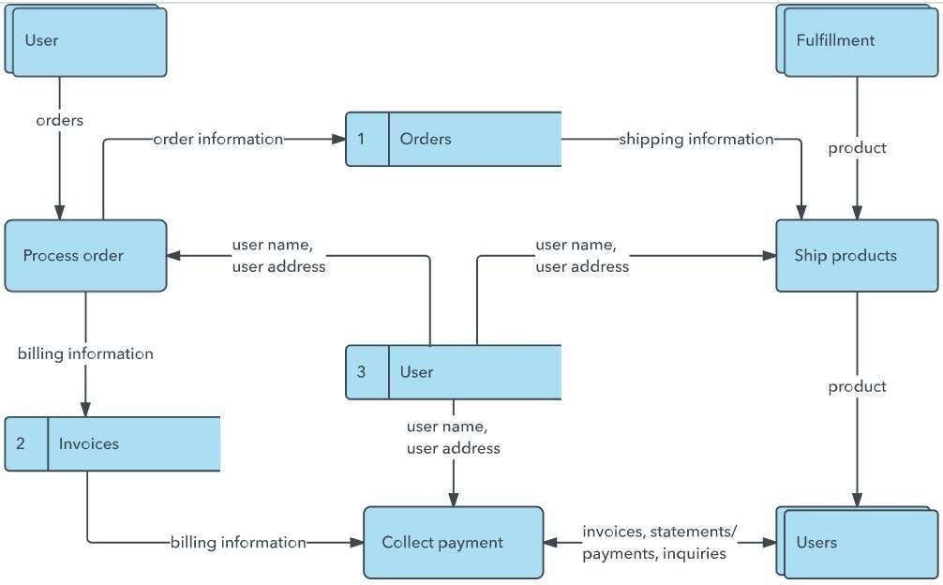

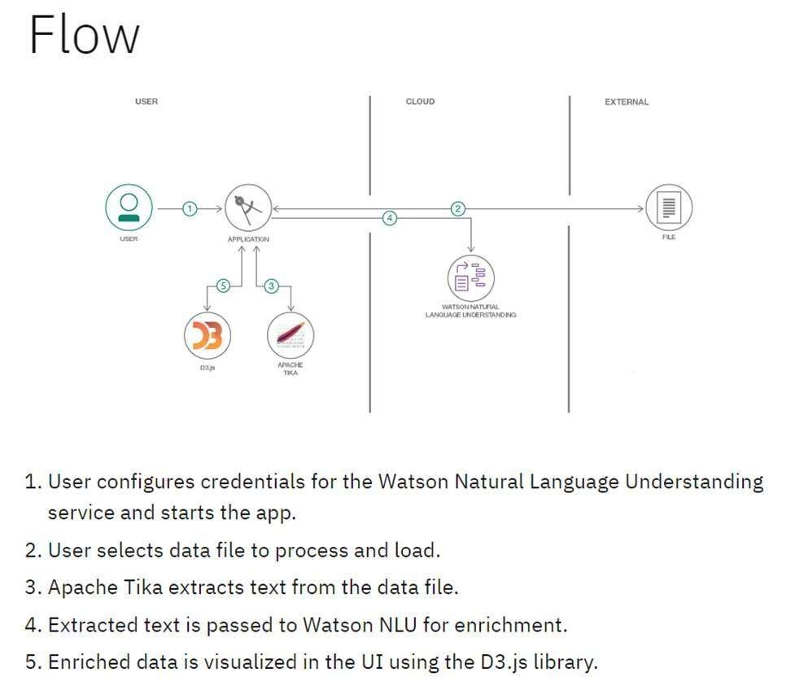

User Stories

|  |  |  |  |  |  |  |
| --- | --- | --- | --- | --- | --- | --- |
| User Type | Functional  Requirement  (Epic) | User Story  Number | User Story / Task | Acceptance Criteria | Priority | Release |
| Customer  (Mobile user) | Registration | USN-1 | As a user, I can register for the application by entering my email, password, and confirming my password. | I can access my account / dashboard | High | Sprint-1 |
|  |  | USN-2 | As a user, I will receive confirmation email once I have registered for the application | I can receive confirmation email & click confirm | High | Sprint-1 |
|  |  | USN-3 | As a user, I can register for the application through Facebook | I can register & access the dashboard with Facebook Login | Low | Sprint-2 |
|  |  | USN-4 | As a user, I can register for the application through Gmail | I can register & access the dashboard using Gmail login | Medium | Sprint-1 |
|  | Login | USN-5 | As a user, I can log into the application by entering email & password | I can successfully login and reach the dashboard | High | Sprint-1 |
|  | Dashboard | USN-6 | As a user, I can view my submitted complaints and their status | I can view the complaint list and their current status | High | Sprint-2 |
|  | Complaint Submission | USN-7 | As a user, I can submit a complaint by filling form and attaching files | I receive confirmation after submission and it appears in list | High | Sprint-2 |
|  | Chat | USN-8 | As a user, I can chat with the assigned agent | I can view responses and reply in real time | Medium | Sprint-3 |
| Customer (Web user) | Responsive Web | USN-9 | As a user, I can use the app smoothly from desktop or mobile browser | All functionalities work correctly across devices | Medium | Sprint-3 |
| Customer Care  Executive | Complaint Handling | USN-10 | As an agent, I can view assigned complaints | Assigned complaints are visible on agent dashboard | High | Sprint-3 |
|  |  | USN-11 | As an agent, I can chat with users to solve the issue | Messages are exchanged correctly and stored | High | Sprint-3 |
| Administrator | User Management | USN-12 | As an admin, I can view/manage all users and agents | User and agent list loads properly with edit/delete options | Medium | Sprint-4 |

|  |  |  |  |  |  |  |
| --- | --- | --- | --- | --- | --- | --- |
|  | Complaint Routing | USN-13 | As an admin, I can assign complaints to agents | Assigned agent receives the complaint in their dashboard | High | Sprint-4 |
|  | Dashboard  Analytics | USN-14 | As an admin, I can view analytics such as total complaints, resolved, pending etc. | Analytics dashboard loads with charts and counts | Medium | Sprint-4 |